8-BIT SUBTRACTION

EXP NO: 2

AIM:
To write an assembly language program to
implement 8-bit subtraction using 8085 processor.

ALGORITHM:

1) Start
the program by loading the first data into the accumulator.

2) Move
the data to a register.

3) Get
the second data and load it into the accumulator.

4) Subtract
the two register contents.

5) Check
for borrow.

6) Store
the difference and borrow in the memory location.

7) Halt.

PROGRAM:

LDA 8000

MOV B, A

LDA 8001

SUB B

STA 8002

RST 1

INPUT:
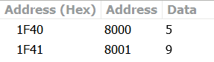

OUTPUT
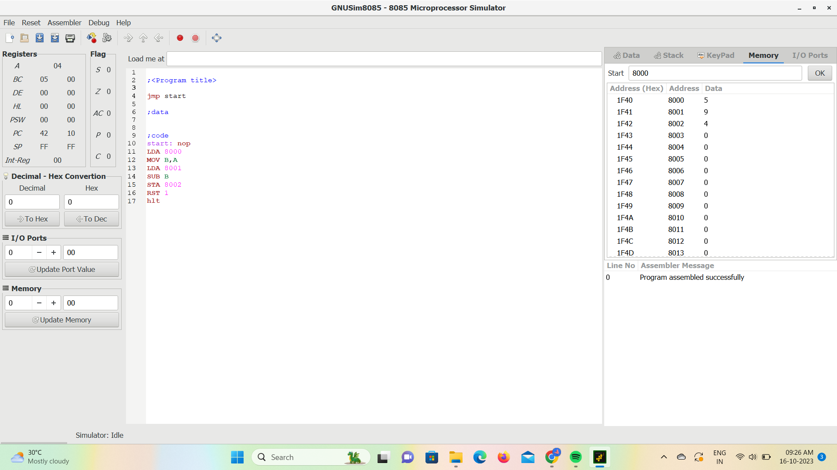

RESULT: Thus
the program was executed successfully using 8085 processor simulator.

